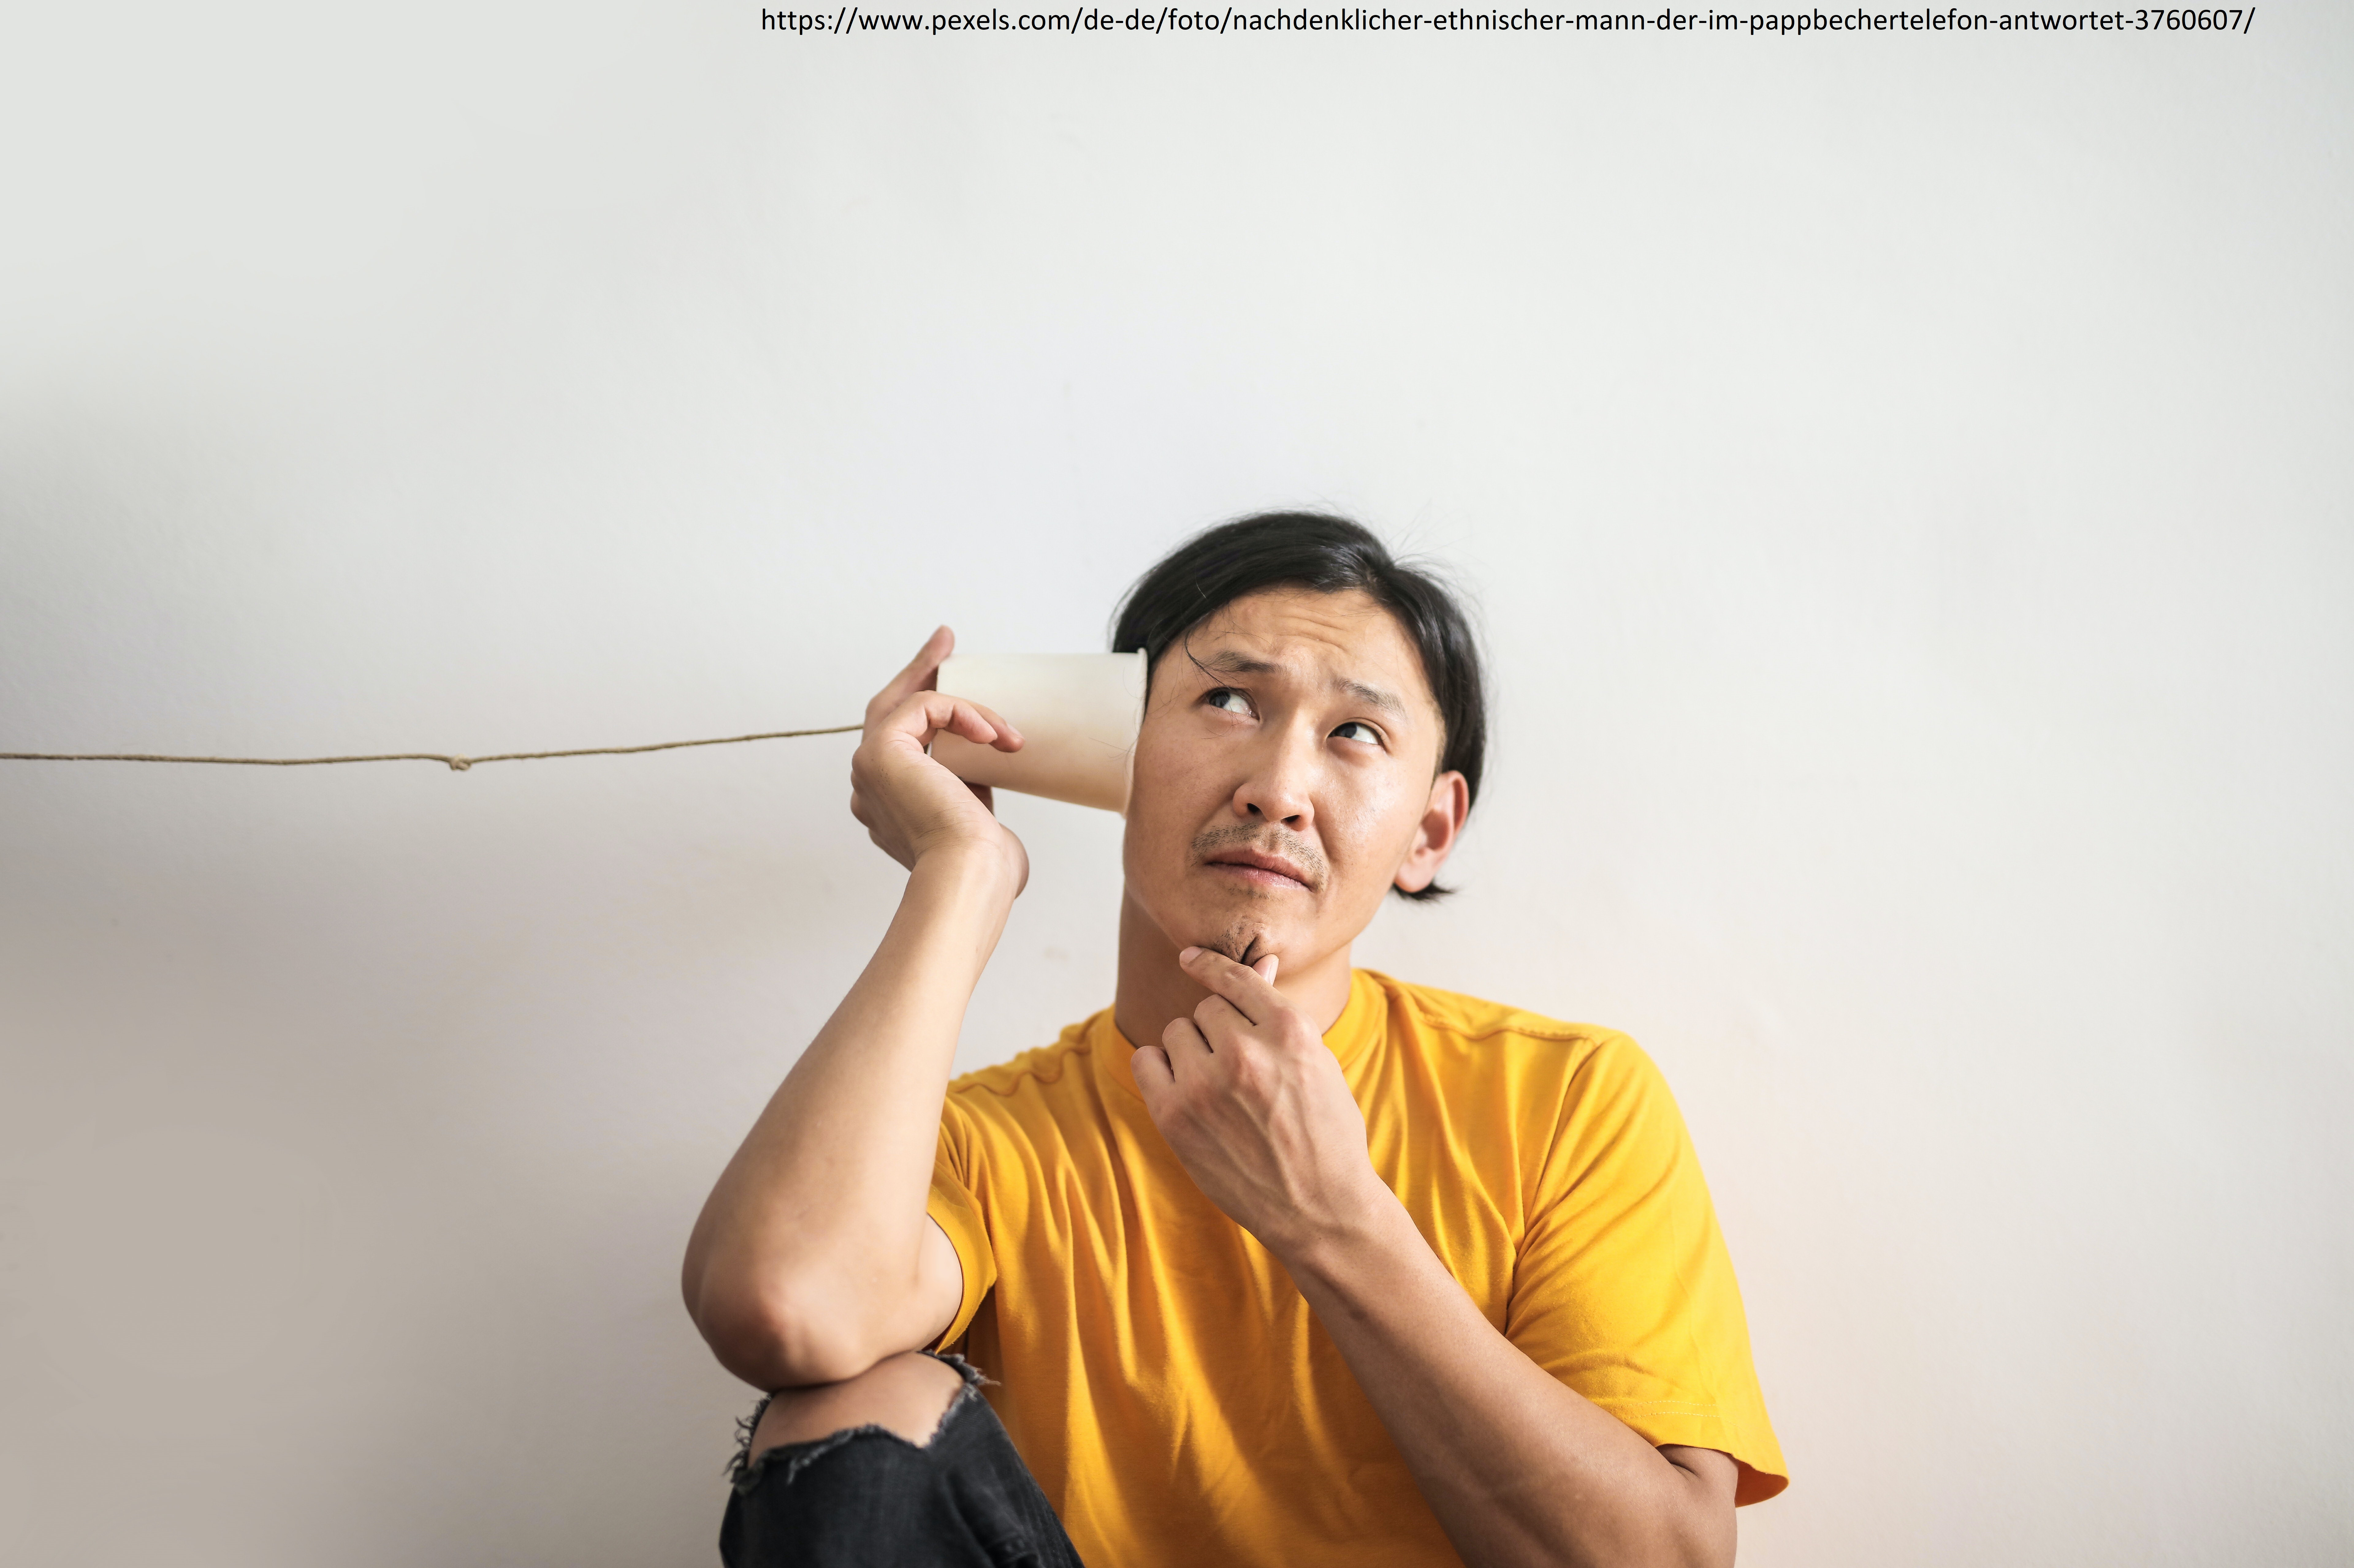

https://www.pexels.com/de-de/foto/nachdenklicher-ethnischer-mann-der-im-pappbechertelefon-antwortet-3760607/

#3 Communication

SHORT DESCRIPTION AND LEARNING Goal

Talking and understanding can sometimes be difficult. That's why today we're going to talk about communication. Human beings cannot "not communicate". Talking always involves feelings. Even in silence, a person expresses something.
Sometimes people misunderstand each other. This can lead to conflict.
Today the trainees will learn to communicate well - in theory and practice!

Process

No. | Content | Duration | Material
1 | Warm-up | 10-20 minutes | 2-3 pictures, pens and paper
2 | Definition | 5 minutes | poster, pens
3 | How does communication work? | 5 minutes | -
4 | Verbal and non-verbal communication | 10 minutes | -
5 | Exercise communication | 10 minutes | small cards
6 | „You cannot not communicate“ | 10 minutes | poster with quote
7 | The four levels of a message | 5 minutes | -
8 | Communication tips | 10 minutes | -

Warm-Up

Silent mail
Everyone sits in a circle. The game leader thinks of a word or a sentence. They whisper this sentence into the ear of the person sitting next to them. This continues until the last person. This person says the sentence out loud. What has arrived at the end of the circle?

Painting in teams
The trainees form pairs. The trainees sit back to back. Person A gets a picture. Person B gets pens and paper. Now person A has to describe their picture. Person B draws what person A describes. Compare the two pictures.

It's not easy to say something and understand it. Sometimes I get something different from what I wanted to say.

Definition
Questions to the trainees (Answers can be collected on a poster):
What is communication?
What ways of communicating do you know?

Communication is the exchange of information.
Communication is the sending and receiving of information.
Communication takes place in different ways.
Example: I send my best friend a WhatsApp message. I give her some information about myself. My friend notices the message. That is communication.

Communication is sometimes complicated. Other people can misunderstand our words. Our body and tone of voice also play a part. This influences the listener. Misunderstandings can occur.

How does communication work?
decrypt
encrypt
Recipient
Message
Sender

Questions to the trainees:
Can you give an example of this picture?

Verbal and non-verbal communication
Messages contain verbal (spoken) and non-verbal (unspoken) parts.

Verbal Components | Non-verbal Components
Sentence structure, word choice, language, tone of voice, volume, speed, emphasis, ...  Everything that is said and heard. | Posture, body language, facial expression, eye contact  Everything that is not said but is seen.

When we communicate, verbal and non-verbal parts should fit together. Sometimes the spoken and unspoken parts contradict each other.

Example: A friend is late for a meeting. I don't want to show that I'm sad. I say: "It's all right". But my voice is shaking. I don't stand up straight. My words and my body language don't match.

Exercise Communication
Now let's do an exercise. It is clear: verbal and non-verbal communication belong together!

Some scenes are described on cards. The trainees are allowed to play the situations to the group. The others observe. The trainees think together: What doesn't fit here?

- Statement: I'm so looking forward to the trainee course later!
I can't wait at all.
Body language: tired, bored

- Statement: I don't mind at all if you meet up with Layla!
Body language: arms crossed, looking down, voice offended

- Statement: But I don't have to go to the toilet!
Body language: crossed legs, cramped hands, bobbing from one leg to the other

Question to the trainees:
Do you know some more examples?

„You cannot not communicate“
On the poster, the trainees see a quote from the scientist Paul Watzlawick.

Questions to the trainess:
What does this quote mean?
It doesn´t matter if you use words or not: It is impossible for us to not communicate even when we’re silent. Our body is always sending a message. Even not reacting is communication. It could mean: I´m not interested.

Questions for the trainees:
Have you ever experienced this?
Can you think of any examples of the quote?

The for levels of a Message

Everything we say has different meanings. Another communication scientist, Friedemann Schulz von Thun, says that every message has four layers.

Recipient
Sender
Self Revelation Level
Relationship Level
Appeal Level
Subject Level
Message

- Obejective layer: Objective Information
- Appeal layer: The recipient of the message should do or not do something
- Relationship layer: What does the sender think about the receiver? How do they relate to each other?
- Self-revelation layer: Information about yourself

A person can be misunderstood or hurt another person because he or she didn´t pay enough attention the different sides a message can have.
An example illustrates the four layers.

Example: It's dirty here.

Objective: It is not clean and tidy.
Appeal: You should tidy your room!
Relationship: Ich muss dich darauf hinweisen. Siehst du es nicht?
Self-revelation: I'm tidier than you are.

The trainees are now trying it themselves. What messages are in these statements?

  - There's something green in the soup
  - It's really cold outside today
  - You can also open the windows

Communication-Tips

Questions for the trainees: What ideas do the trainees have? How can communication work well?

The rules can be written on a poster:

- Listen precisely!
- Ask again if there are still questions!
- I talk about myself!
- … ?

The One-to-one conversation

1. What is your favourite topic to talk about?
2. Who are the persons you talk to most of the time?
3. Are you talking to god sometimes? About what?

good question!

What would you ask god, if you may ask him one question?

Vanessa Gunesch
Yasin Adigüzel

© 2011 buch+musik, ejw-service gmbh. This course unit has been linguistically adapted and supplemented.

