# 

Foto von Ryan McGuire auf Pixabay

# #2 Personality

## DISG-Test of Personality

Today it’s about trainees. With a test we would like to see: what is their power? How do they deal with other human beings? How do they solve problems?

## process

|  |  |  |  |
| --- | --- | --- | --- |
| No. | Content | Duration | Material |
| 1 | Explain definitions | 10 min. | little cards |
| 2 | Play  „in the lift“ | 5 min. | gummy bears |
| 3 | Evaluation of the play | 10 min. | poster, permanent marker |
| 4 | Model of DISG (model of personality) | 10 min. |  |
| 5 | Abstract | 10 min |  |
| 6 | Questionaire | 45 min | questionaires, pens |
| 7 | Evaluation of the test | 20 min. |  |
| 8 | Discussion |  |  |

## explain definitions

The test contains 104 sentences. Some of them are difficult to understand. Sentences, marked with a little * are written on cards. They are up to the table.

At the beginning (for example while lunch) trainees are looking at the sentences. Are they understandable? What do they mean?

## play „in the lift“

At next the trainees get to know four persons. Four colleagues present in a excessive way different persons. It‘s also possible that two colleagues could also act two persons each. Using objects (sunglasses, scarf, cap, handbag) or name plate make visible who they are.

|  |  |  |  |  |  |
| --- | --- | --- | --- | --- | --- |
| Personen | | | | | |
| Dan  (dominant) | | Isabelle  (**i**nitiativ) | Steffen  (**c**onstant) | Gökce  (**c**onscientious) | Narrator |
|  | | | | | |
| Narrator | Narrator: „Four persons are on the way in a house.  Dan would like to take the lift.  Isabelle thinks that’s great. Steffen and Gökce say nothing. They get in. Dan presses the button: forteenth floor. The lift starts. Dan and Isabelle talk together. The two others are quiet. Suddenly the lift stops. Everyone get frightened.“ | | | | |
| Isabelle | *She is afraid.* „We are stuck…..!“  *She cries for help:* „Help, help, we are stuck!“ | | | | |
| Gökce | *She looks around, scratches her head, reflects.* | | | | |
| Steffen | *He watches the scene from a corner.* | | | | |
| Dan | „Never fear. Everything will be fine. Leave here (pushes the others aside), I'll do it.” He presses all the buttons wildly. | | | | |
| Steffen | *He quietens Isabelle*: Everything is going to be alright. Don’t be afraid! I have seen there before. You have to breathe in and out deeply. Yes, that's good...". | | | | |
| Gökce | *She finds a tablet:*  „Oh maybe there is a tip. I am reading….“ *She reads with a low voice.* | | | | |
| Dan | *He grumbles:* “ What a foolish technology?“  *He is beating angrily on the buttons*. „It doesn’t really function!“ | | | | |
| Isabelle | *She is still afraid. She talks to Dan:*  „Bring it on, now! - I’m very frightened. It’s so tight here. In a moment I will weep…“ | | | | |
| Gökce | *She says softly and cautiously*: „Listen here! There is something written on the tablet.“ | | | | |
| Steffen | *He asks for silence:* Hello, could you all listen to Gökce?“ | | | | |
| Gökce | *She reads slowly:*  If the lift is out of order:   1. Convert the lever 2. Press the button at the top right 3. In case this doesn’t work, ring the bell three times and wait for an answer | | | | |
| Steffen | „All right, I do that.“ *He converts the lever and waits.*  „It doesn’t work. Now I ring the bell three times…“ | | | | |
| Dan | „Steffen, let me get it.  *He pushes Steffen aside and rings the bell three times.*  *A voice reports* | | | | |
| Narrator | „Good afternoon! How can I help you?“ | | | | |
| Isabelle | *She shouts excited*: „Help us, save us! The lift is out of order.  Please come quickly…!“ | | | | |
| Narrator | „In which floor are you?“ | | | | |
| Isabelle | „I don’t know. Get us out of here, finally…“ | | | | |
| Gökce | *Is helping*: „Hum, well we are just around between the second and third floor.“ | | | | |
| Narrator | „Please keep calm. I call the care taker.“ | | | | |
| Dan | „Fantastic. Now we have to wait a long time and drink tea.  What a bummer! I must go to my training!“ | | | | |
| Isabelle | *She is joyous again:* „Guys, I’ve got an idea – let’s have a lift-party …Is anybody here, who has some sweets? Now I need a chocolate. Let’s settle in!“ | | | | |
| Steffen | He unwraps gummy bears or chocolate:  „Yes I’ve something with me. Good appetite!  All are sitting down on the ground floor and are talking together. | | | | |

## Evalutation of the play

On a poster at a wall or on a board are the great initial letters of the involved persons **D, I, S, G**.

Trainees are describing the behaviour of the different characters.

The result is written down next to the initial letters.

*Question for the trainees: Where would you see yourself?*

## Model of DISG

An American developed this Model of DISG nearly 100 years ago.

He would like to understand: How do human beings behave?

How do they handle with problems? How do they solve conflicts?

Have a look to the model of DISG:

3

1

4

2

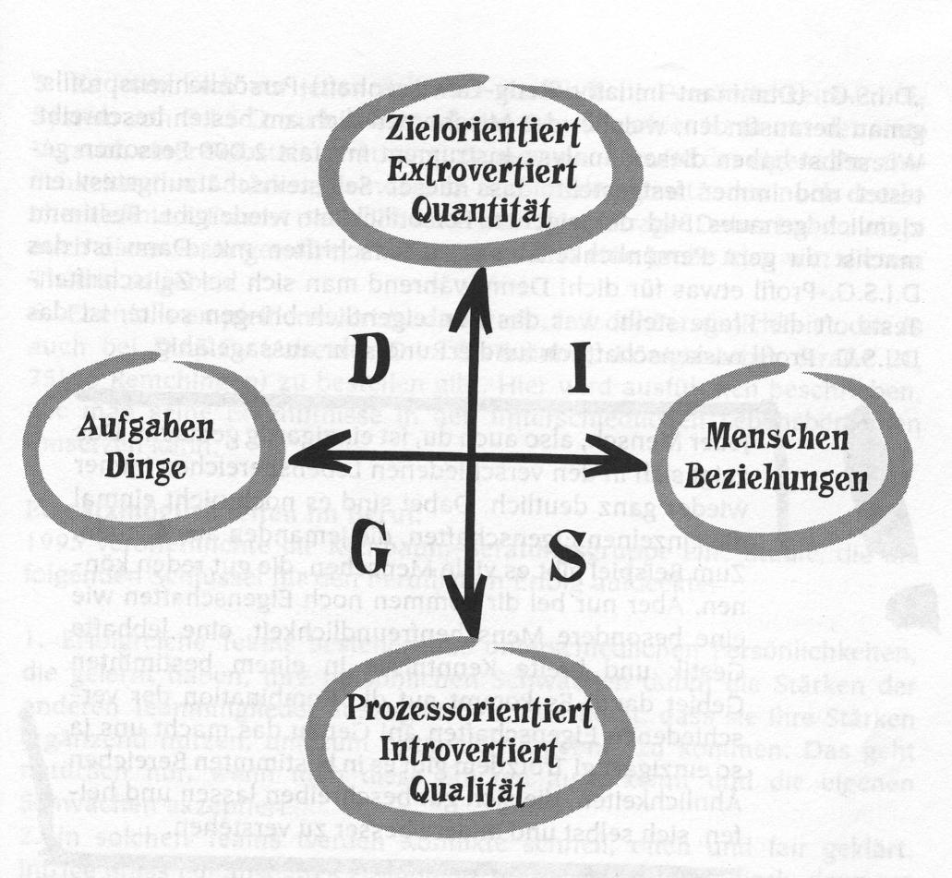

**goal oriented**

**extroverted** *(open-minded, frank, active)*

**quantity***(like to manage a lot)*

**duties**

**objects**

**Human beings**

**relationships**

**process oriented**

**introvert** *(cautious, quiet, careful)*

**quality**

*(like to manage well)*

*d*

This model differs our behaviour from four trends.

1. Is a person active, open-minded, does he or she like change? (up arrow)
2. Or is a person cautious, careful and does he or she like fixed processes? (down arrow)
3. Does the person like to be together with other persons? (arrow to the right)
4. Or does the person be engaged with duties and objects? (arrow to the left)

**Description of the four personality types**

Top left there are the **„dominant“** characters. They like adventure, speed and animation. They stimulate people and objects. They would like to have fast results and take decisions.

Top right there are the **„initiative“** characters. They like change and speed, adventures and freedom, like dominant human beings. But a few topics are different. Initiative characters are very focused on human beings. They like to stand in front of a group of people.

They like to talk. They like to be together with a lot of people.

They think positive about themselves and others.

At the bottom right there are **„constant“** characters. They like quality, stability, regularity and structure. They like to be together with people, as well. Constant human beings want that all people are friendly to each other. They would like to have good and profund relationships. But, constant persons don’t like to be together with people. They prefer to work in little and well-organised teams. Constant persons have rather less relationships. But these relationships are profund and trusting.

At the bottom left there are the **„conscientious“** characters. They pay attention to quality and stability – like constant characters. They are accurate. They prefer to work in the context of duties and projects to people. Conscientious persons enjoy concentrating on details. They like punctuality. They like best to work by oneself and undisturbed.

**Nobody could be classified in absolute dominant, initiative, constant or conscientious trend.**

Everybody has different parts from the four directions in him or her.

*Question for the trainees: Do you know your personal mix?*

Everybody is made by God in an unique way, you as well! Some things are together with other people. But not everything. For example there are a lot of people, who talk well. Other people work very proper.

Simply in relation to you other characteristics are added. For example a special kindness, a catching laught or a lot of knowledge on a certain topic. It depends on combination of various characters. That’s it, which makes us unique! Model of DISG would like to help us, to understand oneselves and others better.

## Outline „four DISG-Types“

|  |  |
| --- | --- |
| Dominant character **Strength**   * result/goal oriented * takes decisions easily and quickly * likes challenge and adventure * independent * makes a proposal   Teamwork: dictates direction, moves s.th.  Lidership role: managing problems and trouble  **weakness**   * impatient * few contacts * poor listening * decides hastily * bad integration in a group * expects too much from others * overlooks risks   **ideal circumstances**   * freedom of decision * challenges * great projects * independent working * as little control as possible * as little detailed working as possible * precise goals | **Initiativ character**  **Strength**   * sociable * propagates optimism and enthusiasm * can enjoy life to the full * is happy to communicate well * spreads good mood   Teamwork: establishes contacts  Lidership role: enables open conversations,  wants everyone to agree all the time  **weakness**   * needs appreciation * bad oranised * doesn’t like conflicts * doesn't finish what has been started * Talks too much * Can’t be alone very well * Little detailed work   **ideal circumstances**   * variety * people * time to enjoy * little detailed work * flexibility * time for conversations * public appreciation |

|  |  |
| --- | --- |
| **constant Character**  **Strength**   * creates harmony * fits well in a group * listens well * loyal * reliable   Teamwork: harmonises, carries out special work  Lidership role: helps others to manage their work  **weakness**   * indecisive * cannot say „no“ * avoids conflicts * willing to compromise * puts on wishes aside too quickly * difficult to cope with change   **ideal circumstances**   * security and stability * enough time to adjust to change * working in a group * appreciation for own person * clarified expectations * harmonious enviroment * clear an good relationships | **Conscientious Character**  **Strength**   * likes details * quality is important to him * thinks critically, reports * much perseverance * observes rules   Teamwork: pays good attention to important details  Lidership role: wants tasks tobe completed and rules to be followed  **weakness**   * losses the overview * wants to do things in a perfect way * watches instead of helping * „to do things right“ has too much importance * little flexibility * takes decisiones too slowly * pessimistic   **ideal circumstances**   * clarified circumstances * regulations * reason for change * appreciation for work * clear tasks * possibility to ask * tasks where one has to be precise |

## Questionnaire

Each Trainer recieves a questionnaire. Together the trainees go through the questionnaire line per line. In every line they make a little cross. On the scale from - 4 to 4.

Then the trainees swap the questionnaires among themselves. Only the little crosses located to the left side (thus - 4 to 0) are important.

Figures marked with a little cross will be added without the minus sign. Result is written in a summary at the end of the questionnaire. For which character the result is the greatest?

This ist he character you corresponds most. Generally there are mixtures between two or more different characters.

## Discussion about the resultS

*Questions for the trainees: Are you surprised? Are you content with the result? Does the result fell right?*

A good team consists of different personalities. Strength of one group balances to the weakness of the other group. It is good to know the own strength well. But it‘s also important to accept the own weakness.

*Question for the trainees: Which strength of your colleagues balances your weaknesses?*

I am pleased to get a task, where I can place my strength in. This fact is also important by choosing a profession.

*Questions for the trainees: which profession suits your character? Which profession doesn’t suit at all?*

If two or more human beings do something together, conflicts and tensions will turn up. If I know different characters I will be able to understand better: Why does behave the other person in this way? Thus I can manage better with tensions.

*Questions for the trainees: Did you make such an experience?*

*What annoys you most about others?*

## The One-To-One Conversation

Incentives for talking:

1. How did you like the model of DISG?
2. What character of personality are you?
3. Why do you think it‘s helpful, to know these facts?

## Good Question!

Do you think, your are made by God very good, the way you are? Are you content with yourself and your charcteristics?

What strength would you like to have?

Vanessa Gunesch

Yasin Adigüzel

© 2011 buch+musik, ejw-service gmbh. This course unit has been linguistically adapted and supplemented.